Name : Nabil Bachroin

Student ID : M11107814

Course : EO5120701 – Microsensors

Friday, 8-December-2023

**(Image Sensor Fabrication and Application)  
CMOS Sensor Fabrication and Application in real-time**

1. The fabrication process of CMOS Sensors

The process of manufacturing a CMOS sensor involves a series of very specific and complex steps. Broadly speaking it usually involves the following steps:

1. Silicone Cleaning

This process starts with very thin wafers of pure silicon. Pure silicon was chosen because of its semiconducting properties. These wafers are cleaned to ensure that there is no dust or other debris.

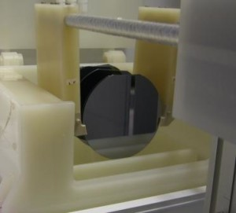

**Fig 1.** Wafer Cleaning Process  
*(Source :* [*https://www.modutek.com/wp-content/uploads/2016/10/wafer-cleaning-process-300x271.jpg*](https://www.modutek.com/wp-content/uploads/2016/10/wafer-cleaning-process-300x271.jpg)*)*

1. Oxidation

The silicon wafer is then subjected to an oxidation process. In this process, the wafers are heated in an oxygen-rich environment. This creates a thin layer of silicon oxide on the surface of the wafer.

  
**Fig 2.** Thermal Oxidation  
*(Source :* [*https://ars.els-cdn.com/content/image/3-s2.0-B9780081019757000105-f10-10-9780081019757.jpg*](https://ars.els-cdn.com/content/image/3-s2.0-B9780081019757000105-f10-10-9780081019757.jpg)*)*

1. Photolithography and Etching

Next, a layer of photoresist, a light-sensitive material, is applied to the wafer. The pattern depicting the transistor components is then projected onto the wafer using ultraviolet light. The photoresist exposed to UV light softens and can be removed in the developing process, leaving the desired pattern on the silicon oxide. The exposed oxide portion is then etched, or 'etched', leaving the exposed silicon.

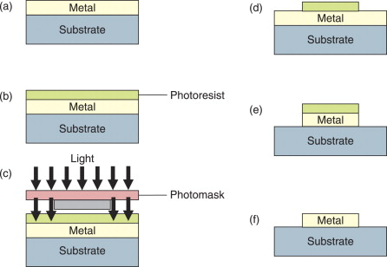  
**Fig 3.** Photolithography process  
*(Source :* [*https://ars.els-cdn.com/content/image/3-s2.0-B9780123743961000349-gr21.jpg*](https://ars.els-cdn.com/content/image/3-s2.0-B9780123743961000349-gr21.jpg)*)*

1. Doping

The exposed portion of the silicon is then subjected to a doping process. In this process, boron or phosphorus ions are implanted into silicon using an ion accelerator. This changes silicon from an intrinsic semiconductor to an extrinsic semiconductor, which has better electrical conductivity properties.

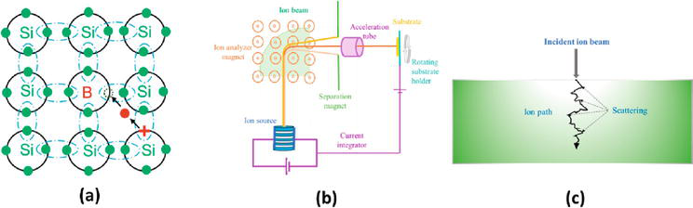  
**Fig 4.** Boron Doping  
*(Source :* [*https://cdnintech.com/media/chapter/83080/1512345123/media/F1.png*](https://cdnintech.com/media/chapter/83080/1512345123/media/F1.png)*)*

1. Installation of Electrodes and Connectors

After all the transistors have been made, they need to be connected. This is achieved by adding a layer of metal such as aluminum or copper to the surface of the wafer. This layer is then subjected to a photolithography process and etched again to form the connection paths between the transistors.

1. Testing and Sorting

After the fabrication process is complete, each chip is tested for quality and functionality. Chips that pass the test are then cut from the wafer and packaged before shipping to end users.

1. CMOS sensor application in real time

Real-time applications of CMOS sensors cover a wide range of sectors, including surveillance, automotive, telecommunications and medical. At this time I want to provide the application of a CMOS sensor that is used in automotive, namely the use of a camera in a Tesla electric car that has a self-driving feature. Tesla has consistently emphasized that they do not use LiDAR (Light Detection and Ranging) in their autonomous car technology. Instead, Tesla relies on a combination of other sensors, including cameras, radar and ultrasonics, to aid in the navigation of their autonomous vehicles.

The vehicle is equipped with a series of CMOS cameras which are used to detect and interpret the environment around the car. This data is used in real-time to make decisions about how to control the car, such as when to turn, slow down, accelerate or stop the vehicle.

Each camera on the vehicle captures visual data from a different environment, with some cameras focused at a distance, some at an intermediate distance, and some at a close range. This data is then processed by onboard hardware and software that uses sophisticated machine learning algorithms to understand the environment and make safe and efficient driving decisions. This is an example of a real-time application of a CMOS sensor where speed and accuracy of capturing and processing data is critical.

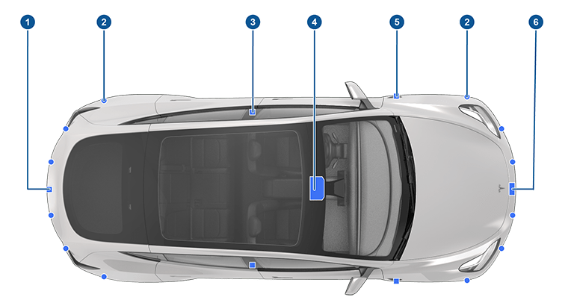

**Fig 5.** Tesla Camera’s  
*(Source* : [*https://www.tesla.com/ownersmanual/models/en_us/*](https://www.tesla.com/ownersmanual/models/en_us/)*)*

1. A camera is mounted above the rear license plate.
2. Ultrasonic sensors (if equipped) are located in the front and rear bumpers.
3. A camera is mounted in each door pillar.
4. Three cameras are mounted to the windshield above the rear view mirror.
5. A camera is mounted to each front fender.
6. Radar (if equipped) is mounted behind the front bumper.

as seen on the DJI Phantom and Mavic Pro. In these drones, a CMOS sensor is used in the camera to take high-resolution images and videos from the air. This exceptional image quality enables the use of drones for a variety of purposes, from professional photography and videography to infrastructure inspection and geographic mapping. Apart from that, CMOS sensors also play an important role in drone navigation systems. By integrating visual data from the CMOS sensor, this drone is able to perform stable and accurate flights. Furthermore, these sensors provide critical obstacle avoidance capabilities. This obstacle avoidance system utilizes input from CMOS sensors to automatically detect and avoid physical obstacles during flight, increasing drone safety and reliability. This advance marks a major step in drone technology, making flying safer and more efficient not just for hobbies, but also for commercial and scientific applications.

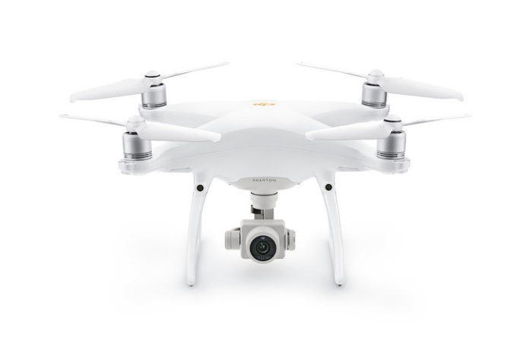

**Fig 6.** Phantom 4 Pro V2.0  
*(Source* : [*https://store.dji.com/guides/phantom-4-pro-v2-vs-mavic-2-pro/*](https://store.dji.com/guides/phantom-4-pro-v2-vs-mavic-2-pro/)*)*

DJI's range of drones, particularly the Mavic 3, Air 2S, Phantom 4 Pro Plus V2.0, Mini 3 Pro, and Mini 3, have been recognized for their effectiveness in mapping and photogrammetry applications​​ [[Source](https://www.droneblog.com/best-dji-drones-for-mapping-and-photogrammetry/)]. The advanced features of these drones, such as the 4/3 CMOS Hasselblad Camera on the Mavic 3, which supports 5.1K video recording, and omnidirectional obstacle sensing, contribute significantly to their versatility [[Source](https://www.droneblog.com/best-dji-drones-for-mapping-and-photogrammetry/)]​​.

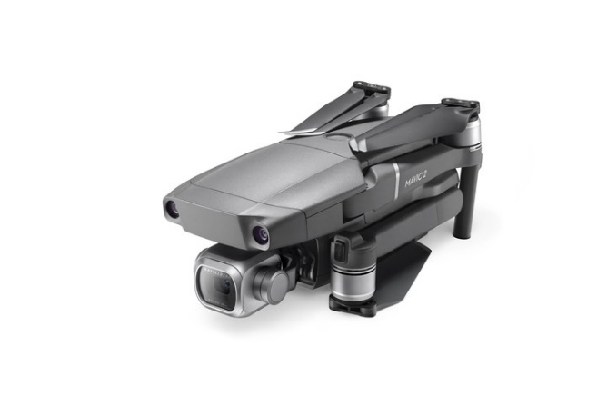

**Fig 6.** Mavic 2 Pro  
*(Source* : [*https://store.dji.com/guides/phantom-4-pro-v2-vs-mavic-2-pro/*](https://store.dji.com/guides/phantom-4-pro-v2-vs-mavic-2-pro/)*)*

The larger than 1 inch CMOS sensors on DJI drones enable the creation of distortion-free images, even at complex angles, which is especially useful for applications that require detailed and accurate imaging. This advanced CMOS technology provides high-quality imaging capabilities, improving drone performance and reliability, making it suitable for a variety of real-time applications in areas such as topographic surveying, agriculture, and the oil and gas industry [[Source](https://www.droneblog.com/best-dji-drones-for-mapping-and-photogrammetry/)].